**Login for locked out user**

Step 1: Navigate to swag labs site using the URL- <https://www.saucedemo.com/>

Step 2: Provide the username. Given: Username= locked_out_user

Step 3: Provide the password. Given: Password= secret_sauce

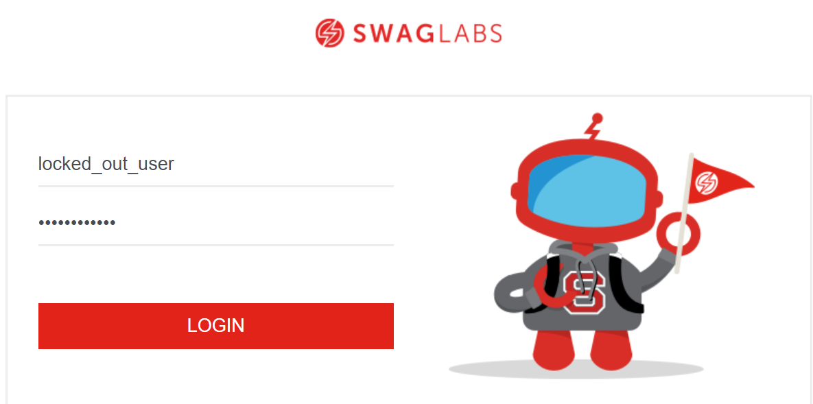

Step 4: Click on login button and user should not be able to login.

Step 5: It should display a message “Epic sadface: Sorry, this user has been locked out.”

